Class Diagram

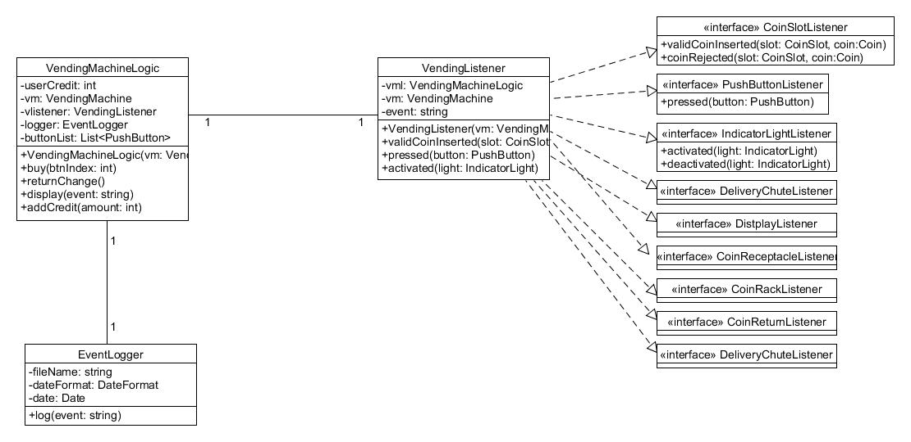

This class diagram shows the three classes we implemented. The VendingMachineLogic consists of the userCredit, an instantiated object of the VendingMachine Hardware, an EventLogger and a VendingListener. The method addCredit is used to add the inserted coins so that the customer can buy a pop. If he selects a pop the buy() method is called. Besides that the method returnChange() is used to give the customer the change back and the display() method shows messages on the VendingMachine display.

The VendingListener implements all necessary interfaces to the machine hardware. Through implementing them we can process certain events i.e. when a valid coin was inserted.

The EventLogger is used at certain events to write them into a logfile. It is implemented to improve the maintainability of the vending machine.

There are more variables and methods but this diagrams shows the most important ones.

Activity Diagram

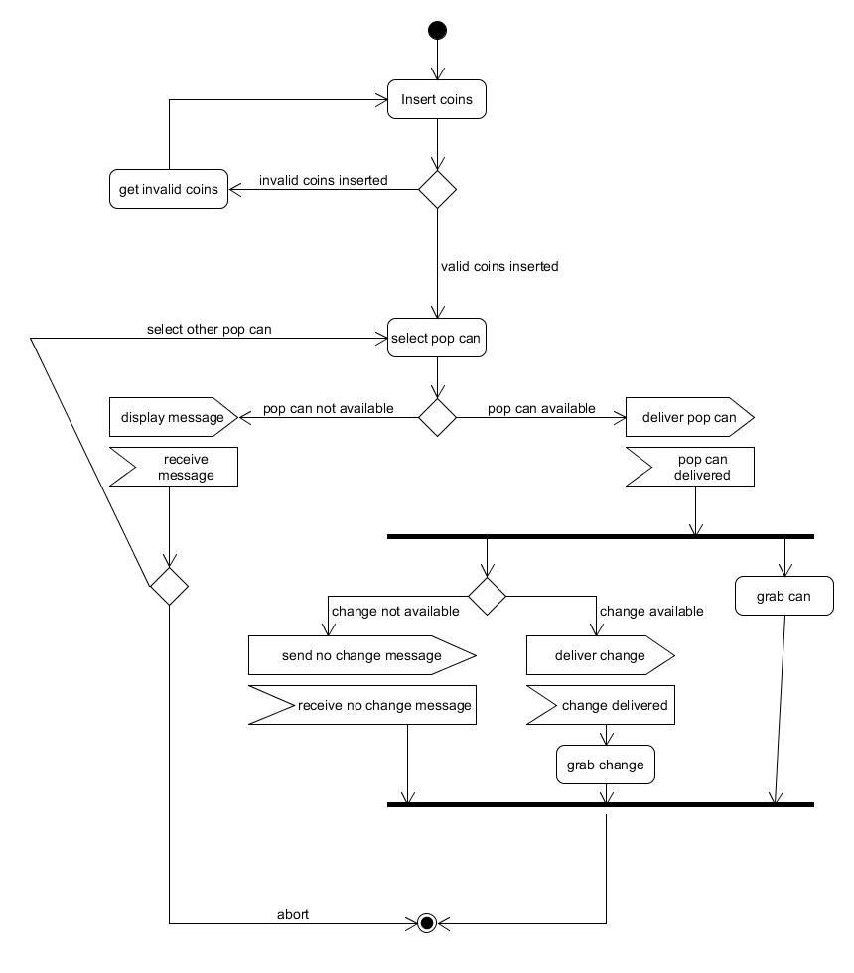

This activity diagram shows activies from the customer view. When the customer inserts coins the machine checks if the coins are valid, if not the customer gets them back and can insert valid coins after that. If he inserts valid coins he can select a pop can. If the pop can is not available he can abort or select another pop can. If the pop can is available the machine delivers the pop can, if change is available the user gets the change and he grabs his can. Those activities run simultaneously, after the pop was delivered through the chute.